# **Cognizant Digital Nurture 4.0 - Week 7 ReactJS Hands-on Labs**

**Name:** Nirbhik Mandal  
 **Roll Number:** 22053081  
 **Program:** DotNet Full Stack Engineer (FSE) Deep Skilling  
 **Week:** 7  
 **Technology:** ReactJS

## **Lab 1 – ReactJS-HOL 9: ES6 Features in React**

### **Objective:**

* Use map(), arrow functions, destructuring, merging arrays, and conditional rendering with JSX.

### **Code:**

**App.js**

import React from 'react';

import ListofPlayers from './ListofPlayers';

import IndianPlayers from './IndianPlayers';

function App() {

const flag = true;

return (

<div className="App">

<h1>Cricket Application</h1>

{flag ? <ListofPlayers /> : <IndianPlayers />}

</div>

);

}

export default App;

**ListofPlayers.js**

import React from 'react';

function ListofPlayers() {

  const players = [

    { name: 'Jack', score: 50 },

    { name: 'Michael', score: 70 },

    { name: 'John', score: 40 },

    { name: 'Ann', score: 61 },

    { name: 'Elisabeth', score: 61 },

    { name: 'Sachin', score: 95 },

    { name: 'Dhoni', score: 100 },

    { name: 'Virat', score: 84 },

    { name: 'Jadeja', score: 64 },

    { name: 'Raina', score: 75 },

    { name: 'Rohit', score: 80 }

  ];

  const lessThan70 = players.filter(player => player.score < 70);

  return (

    <div>

      <h2>List of Players</h2>

      {players.map((item, index) => (

        <li key={index}>Mr. {item.name} {item.score}</li>

      ))}

      <h2>List of Players having Scores Less than 70</h2>

      {lessThan70.map((item, index) => (

        <li key={index}>Mr. {item.name} {item.score}</li>

      ))}

    </div>

  );

}

export default ListofPlayers;

**IndianPlayers.js**

import React from 'react';

function IndianPlayers() {

  const oddPlayers = ['Sachin', 'Virat', 'Yuvraj'];

  const evenPlayers = ['Dhoni', 'Rohit', 'Raina'];

  const T20 = ['Sachin', 'Virat', 'Yuvraj'];

  const Ranji = ['Dhoni', 'Rohit', 'Raina'];

  const mergedPlayers = [...T20, ...Ranji];

  return (

    <div>

      <h2>Odd Players</h2>

      <ul>

        <li>First : {oddPlayers[0]}</li>

        <li>Third : {oddPlayers[1]}</li>

        <li>Fifth : {oddPlayers[2]}</li>

      </ul>

      <h2>Even Players</h2>

      <ul>

        <li>Second : {evenPlayers[0]}</li>

        <li>Fourth : {evenPlayers[1]}</li>

        <li>Sixth : {evenPlayers[2]}</li>

      </ul>

      <h2>List of Indian Players Merged:</h2>

      <ul>

        {mergedPlayers.map((player, index) => (

          <li key={index}>Mr. {player}</li>

        ))}

      </ul>

    </div>

  );

}

export default IndianPlayers;

📸 **Screenshot Placeholder:** Output for flag=true and flag=false

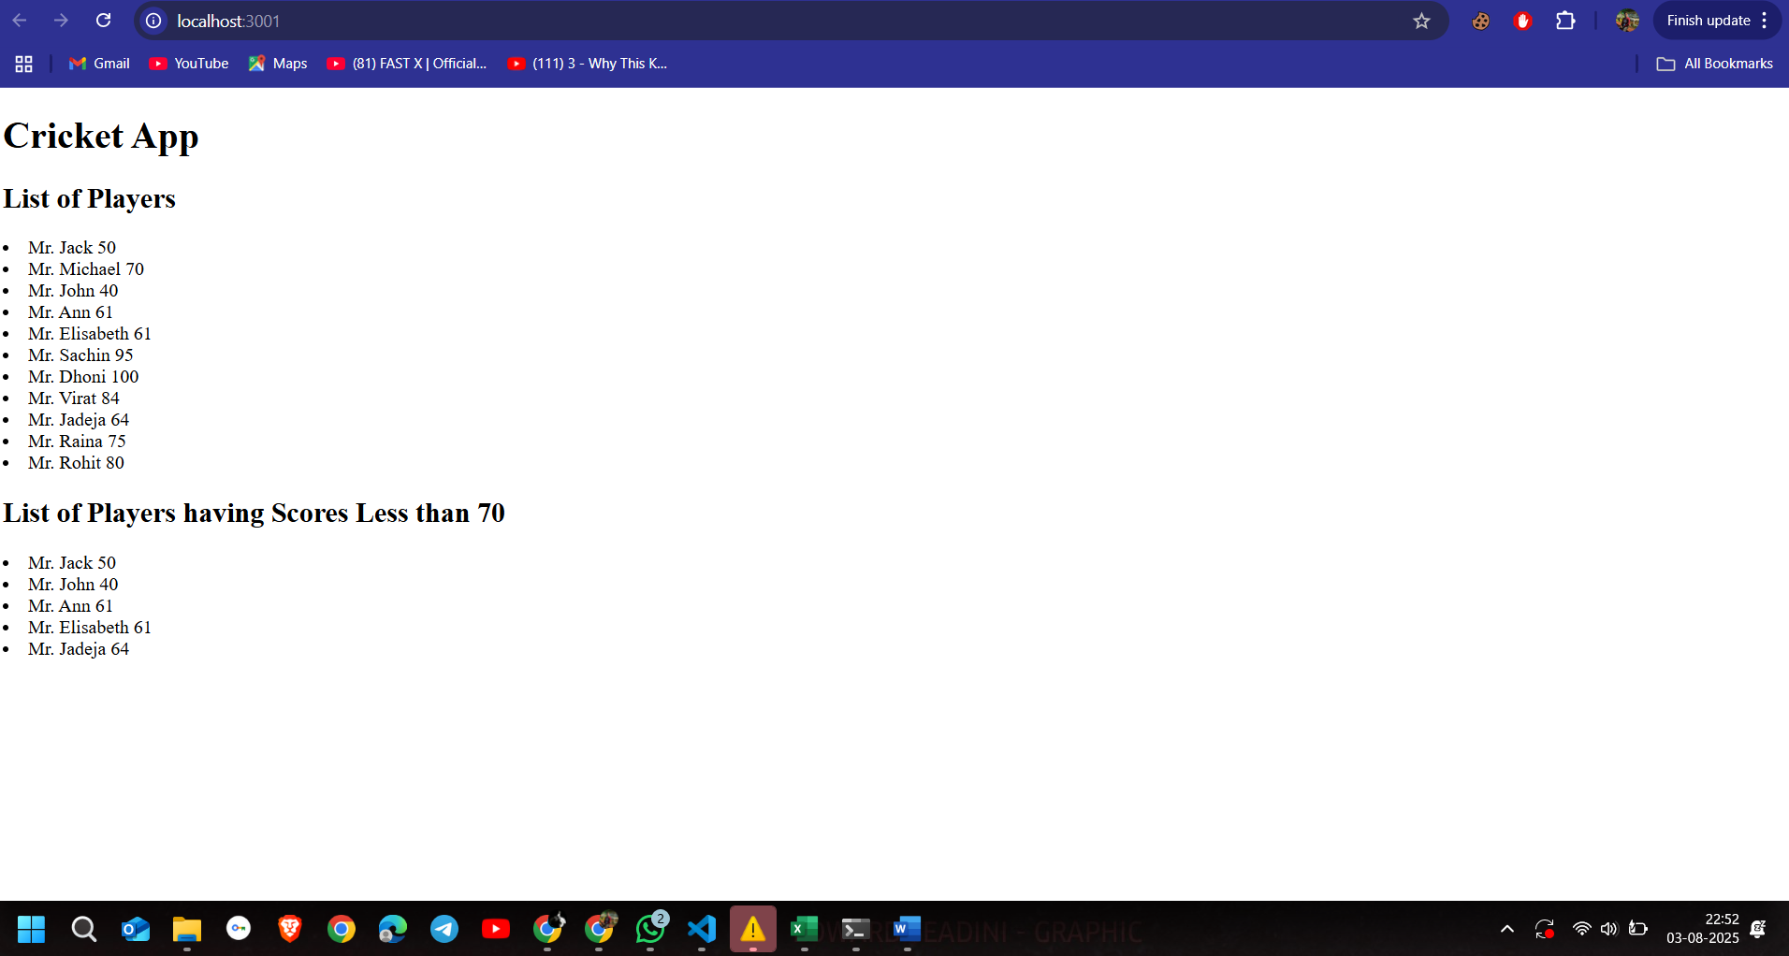

Output for flag=flase and flag=true

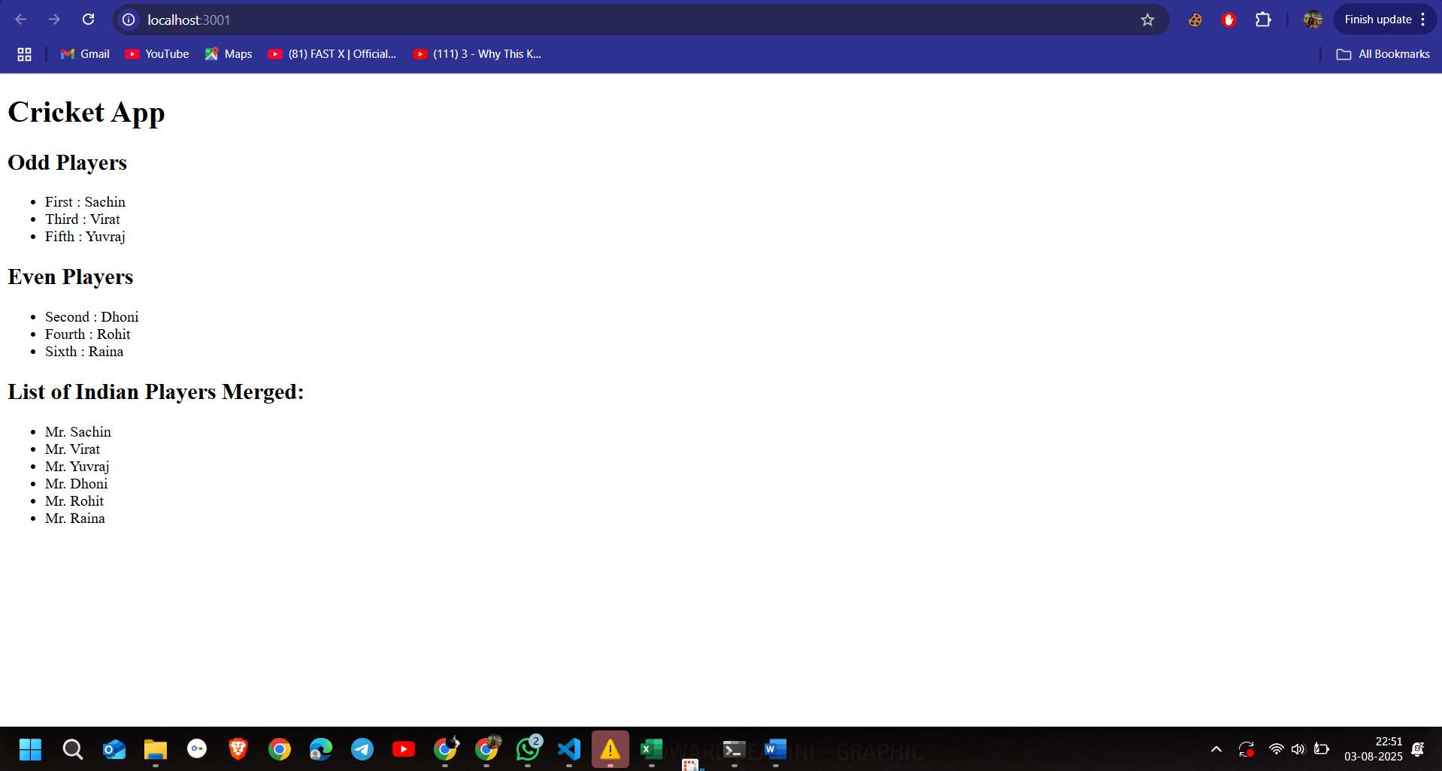

## **Lab 2 – ReactJS-HOL 10: JSX and Inline CSS**

### **Code:**

**App.js**

import React from 'react';

import OfficeList from './OfficeList';

function App() {

  return (

    <div>

      <OfficeList />

    </div>

  );

}

export default App;

**OfficeLists.js**

import React from 'react';

function OfficeList() {

  // heading element using JSX

  const heading = <h1>Office Space Rental App</h1>;

  // image element using JSX

  const image = <img src="C:\Users\Nirbhik\Downloads\download (6).jpeg" alt="Office Space" width="400" />;

  // object of office

  const office = {

    name: "Skyline Office",

    rent: 55000,

    address: "Park Street, Kolkata"

  };

  // list of office spaces

  const officeList = [

    { id: 1, name: "Skyline Tower", rent: 55000, address: "Kolkata" },

    { id: 2, name: "Cyber Heights", rent: 70000, address: "Hyderabad" },

    { id: 3, name: "Tech Park", rent: 60000, address: "Bangalore" },

    { id: 4, name: "Business Bay", rent: 48000, address: "Pune" }

  ];

  return (

    <div style={{ fontFamily: 'Arial' }}>

      {heading}

      {image}

      <h2>Single Office</h2>

      <p>Name: {office.name}</p>

      <p style={{ color: office.rent < 60000 ? 'red' : 'green' }}>

        Rent: ₹{office.rent}

      </p>

      <p>Address: {office.address}</p>

      <h2>List of All Office Spaces</h2>

      <ul>

        {officeList.map((item) => (

          <li key={item.id}>

            <strong>{item.name}</strong> - ₹

            <span style={{ color: item.rent < 60000 ? 'red' : 'green' }}>

              {item.rent}

            </span> ({item.address})

          </li>

        ))}

      </ul>

    </div>

  );

}

export default OfficeList;

📸 **Screenshot Placeholder:** Office listings with styled rent values

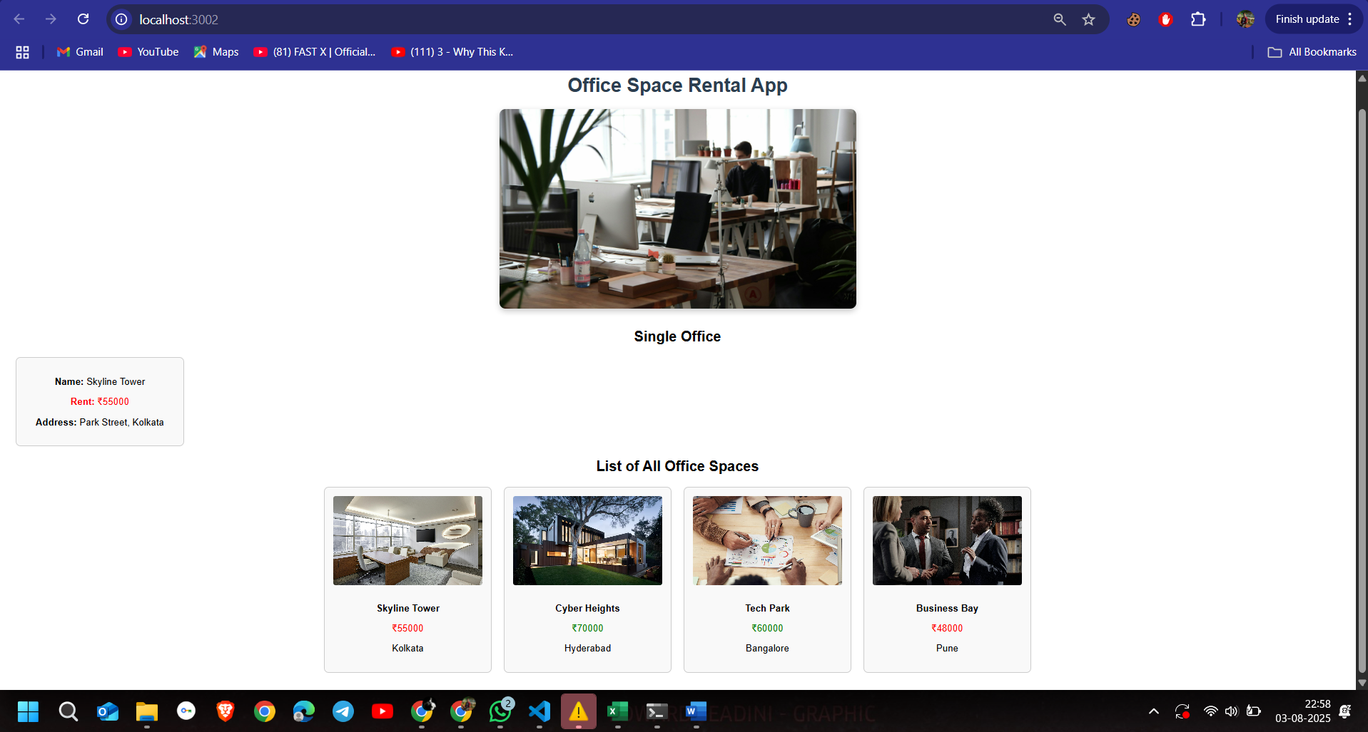

## ***Lab 3 – ReactJS-HOL 11: Event Handling***

### ***Code:***

***App.js***

*import React, { Component } from 'react';*

*import CurrencyConvertor from './CurrencyConvertor';*

*class App extends Component {*

*constructor(props) {*

*super(props);*

*this.state = { count: 0 };*

*this.increment = this.increment.bind(this);*

*this.sayHello = this.sayHello.bind(this);*

*this.handleClick = this.handleClick.bind(this);*

*}*

*increment() {*

*this.setState(prev => ({ count: prev.count + 1 }));*

*this.sayHello();*

*}*

*decrement = () => {*

*this.setState(prev => ({ count: prev.count - 1 }));*

*};*

*sayHello() {*

*alert("Hello! This is a static message from 'sayHello()'");*

*}*

*sayWelcome(msg) {*

*alert(msg);*

*}*

*handleClick(e) {*

*e.preventDefault();*

*alert("I was clicked (Synthetic Event)");*

*}*

*render() {*

*return (*

*<div>*

*<h1>Event Handling Example</h1>*

*<h2>Counter: {this.state.count}</h2>*

*<button onClick={this.increment}>Increase</button>*

*<button onClick={this.decrement}>Decrease</button><br/><br/>*

*<button onClick={() => this.sayWelcome("Welcome to React Events!")}>Say Welcome</button><br/><br/>*

*<button onClick={this.handleClick}>Synthetic Event Button</button><br/><br/>*

*<CurrencyConvertor />*

*</div>*

*);*

*}*

*}*

*export default App;*

***CurrencyConvertor.js***

*import React, { Component } from 'react';*

*class CurrencyConvertor extends Component {*

*constructor(props) {*

*super(props);*

*this.state = { rupees: '', euro: '' };*

*}*

*handleChange = (e) => {*

*this.setState({ rupees: e.target.value });*

*};*

*handleSubmit = (e) => {*

*e.preventDefault();*

*const euro = (this.state.rupees / 90).toFixed(2);*

*this.setState({ euro });*

*};*

*render() {*

*return (*

*<div>*

*<h2>Currency Convertor</h2>*

*<form onSubmit={this.handleSubmit}>*

*<label>₹ Rupees: </label>*

*<input type="number" value={this.state.rupees} onChange={this.handleChange} />*

*<button type="submit">Convert</button>*

*</form>*

*{this.state.euro && <p>€ Euro: {this.state.euro}</p>}*

*</div>*

*);*

*}*

*}*

*export default CurrencyConvertor;*

*📸* ***Screenshot Placeholder:*** *Event buttons and currency conversion output*

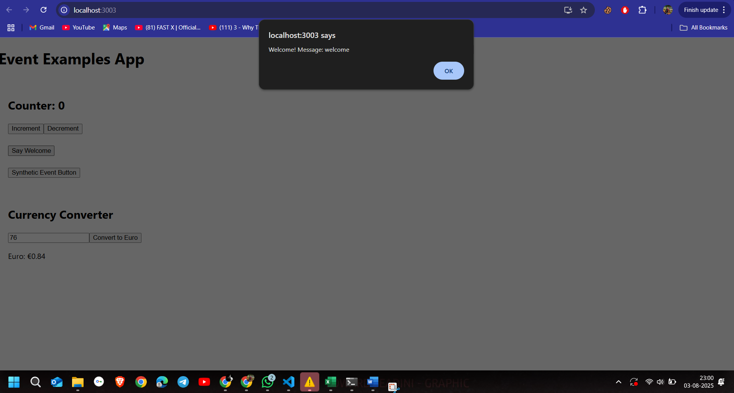

## ***Lab 4 – ReactJS-HOL 12: Conditional Rendering***

***App.js***

*import React, { useState } from 'react';*

*import GuestPage from './GuestPage';*

*import UserPage from './UserPage';*

*import './App.css';*

*function App() {*

*const [isLoggedIn, setIsLoggedIn] = useState(false);*

*const toggleLogin = () => {*

*setIsLoggedIn(!isLoggedIn);*

*};*

*return (*

*<div className="App">*

*<h1>✈️ Ticket Booking App</h1>*

*<button onClick={toggleLogin}>*

*{isLoggedIn ? "Logout" : "Login"}*

*</button>*

*{isLoggedIn ? <UserPage /> : <GuestPage />}*

*</div>*

*);*

*}*

*export default App;*

***Guest.js***

*import React from 'react';*

*import FlightDetails from './FlightDetails';*

*function GuestPage() {*

*return (*

*<div>*

*<h1>Welcome, Guest!</h1>*

*<p>Please login to book tickets.</p>*

*<FlightDetails />*

*</div>*

*);*

*}*

*export default GuestPage;*

***User.js***

*import React from 'react';*

*import FlightDetails from './FlightDetails';*

*function UserPage() {*

*return (*

*<div>*

*<h1>Welcome, User!</h1>*

*<p>You can now book your tickets.</p>*

*<FlightDetails />*

*<button>Book Ticket</button>*

*</div>*

*);*

*}*

*export default UserPage;*

*import React from 'react';*

***FlightDetails.js***

*function FlightDetails() {*

*return (*

*<div>*

*<h2>Flight Details</h2>*

*<ul>*

*<li>✈️ Indigo - Kolkata to Delhi - 8:00 AM</li>*

*<li>✈️ Air India - Mumbai to Bangalore - 10:30 AM</li>*

*<li>✈️ Vistara - Delhi to Chennai - 1:00 PM</li>*

*</ul>*

*</div>*

*);*

*}*

*export default FlightDetails;*

*📸* ***Screenshot Placeholder:*** *Guest vs Logged-in view toggle*

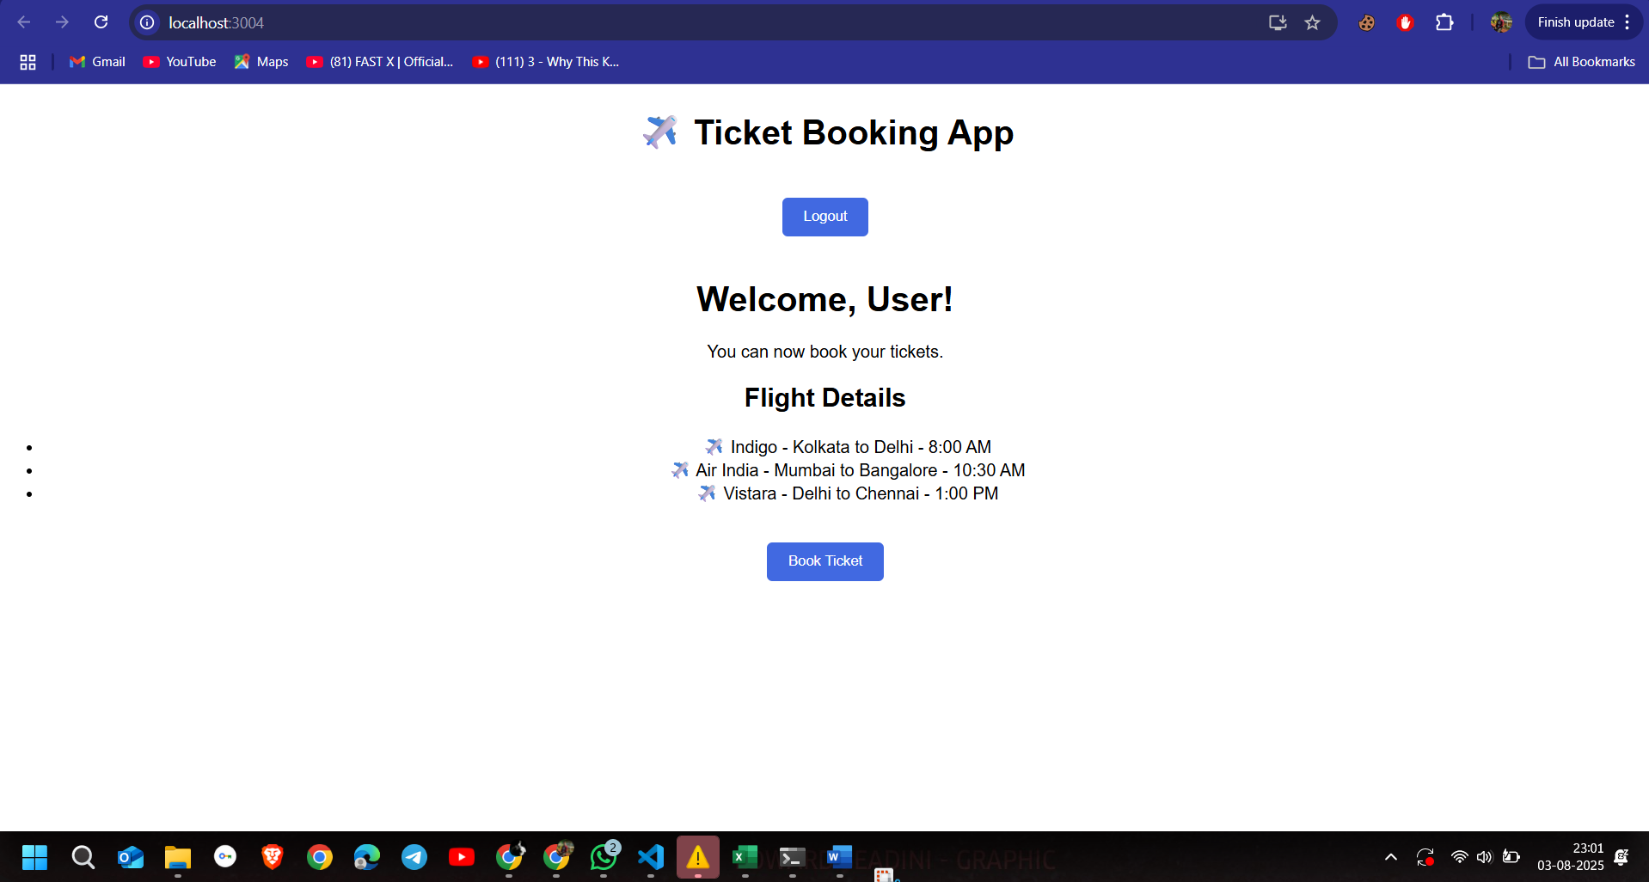

## ***Lab 5 – ReactJS-HOL 13: Conditional Rendering + Lists with Keys***

***App.js***

*import React from 'react';*

*import BookDetails from './BookDetails';*

*import BlogDetails from './BlogDetails';*

*import CourseDetails from './CourseDetails';*

*import './App.css';*

*function App() {*

*return (*

*<div className="App">*

*<h1>📖 Blogger App - All Details</h1>*

*<div className="container">*

*<BookDetails />*

*<BlogDetails />*

*<CourseDetails />*

*</div>*

*</div>*

*);*

*}*

*export default App;*

***CourseDetails.js***

*import React from 'react';*

*function CourseDetails() {*

*return (*

*<div>*

*<h2>🎓 Course Details</h2>*

*<ul>*

*<li>Course Name: Full Stack Development</li>*

*<li>Duration: 3 Months</li>*

*<li>Instructor: Dr. A.P. Tech</li>*

*</ul>*

*</div>*

*);*

*}*

*export default CourseDetails;*

***BlogDetails.js***

*import React from 'react';*

*function BlogDetails() {*

*return (*

*<div>*

*<h2>📝 Blog Details</h2>*

*<ul>*

*<li>Title: Mastering React in 30 Days</li>*

*<li>Author: Jane Smith</li>*

*<li>Views: 1500</li>*

*</ul>*

*</div>*

*);*

*}*

*export default BlogDetails;*

*📸* ***Screenshot Placeholder:*** *All 3 components rendered side-by-side*

